# Advanced Video Analytics

**Lab5-1: Chaining models: Use multiple models in an application**

1. **Set environmental variables**

$ source /opt/intel/computer_vision_sdk/bin/setupvars.sh

$ export SV=/opt/intel/workshop/smart-video-workshop

$ cd $SV/object-detection

1. **Run the executable for the security barrier sample with the mobilenet-ssd* model used in the first tutorial**

$ ./lab.py security_barrier_camera_sample -i car_1.bmp -m mobilenet-ssd -d CPU

InferenceEngine:

API version ............ 1.0

Build .................. 10073

[ INFO ] Parsing input parameters

[ INFO ] No extensions provided

[ INFO ] Reading input

[ INFO ] Loading plugin CPU

API version ............ 1.0

Build .................. lnx_20180314

Description ....... MKLDNNPlugin

[ INFO ] Loading network files for VehicleDetection

[ INFO ] Batch size is forced to 1

[ INFO ] Checking Vehicle Detection inputs

[ INFO ] Checking Vehicle Detection outputs

[ INFO ] Loading Vehicle Detection model to the CPU plugin

[ INFO ] Vehicle Attribs detection DISABLED

[ INFO ] License Plate Recognition detection DISABLED

[ INFO ] Start inference

[ INFO ] Execution successful

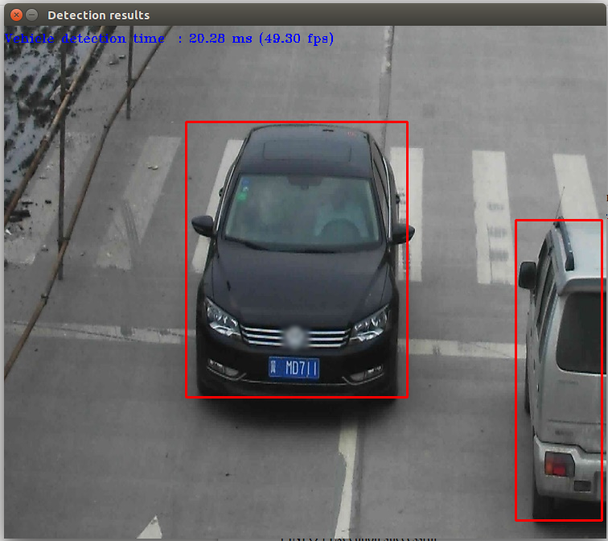

1. **Run the security camera sample with ICV models**

$ ./lab.py security_barrier_camera_sample -d CPU -i car_1.bmp -m vehicle-license-plate-detection-barrier-0007 -m_va vehicle-attributes-recognition-barrier-0039 -m_lpr license-plate-recognition-barrier-0001

InferenceEngine:

API version ............ 1.0

Build .................. 10073

[ INFO ] Parsing input parameters

[ INFO ] No extensions provided

[ INFO ] Reading input

[ INFO ] Loading plugin CPU

API version ............ 1.0

Build .................. lnx_20180314

Description ....... MKLDNNPlugin

[ INFO ] Loading network files for VehicleDetection

[ INFO ] Batch size is forced to 1

[ INFO ] Checking Vehicle Detection inputs

[ INFO ] Checking Vehicle Detection outputs

[ INFO ] Loading Vehicle Detection model to the CPU plugin

[ INFO ] Loading network files for VehicleAttribs

[ INFO ] Batch size is forced to 1 for Vehicle Attribs

[ INFO ] Checking VehicleAttribs inputs

[ INFO ] Checking Vehicle Attribs outputs

[ INFO ] Loading Vehicle Attribs model to the CPU plugin

[ INFO ] Loading network files for Licence Plate Recognition (LPR)

[ INFO ] Batch size is forced to 1 for LPR Network

[ INFO ] Checking LPR Network inputs

[ INFO ] Checking LPR Network outputs

[ INFO ] Loading LPR model to the CPU plugin

[ INFO ] Start inference

[ INFO ] Execution successful

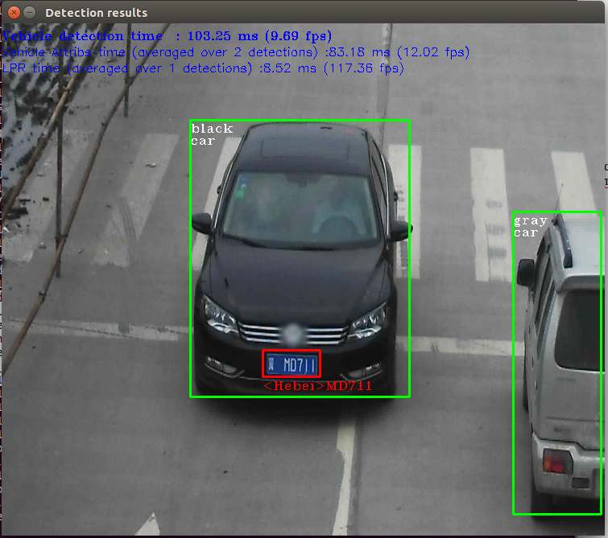

**Lab5-2: Use multiple models on different hardware**

1. **The face detection sample from the OpenVINO™ tookit package**

$ ./lab.py interactive_face_detection_sample -h

InferenceEngine:

API version ............ 1.0

Build .................. 10073

interactive_face_detection [OPTION]

Options:

-h Print a usage message.

-i "<path>" Optional. Path to an video file. Default value is "cam" to work with camera.

-m "<path>" Required. Path to an .xml file with a trained face detection model.

-m_ag "<path>" Optional. Path to an .xml file with a trained age gender model.

-m_hp "<path>" Optional. Path to an .xml file with a trained head pose model.

-l "<absolute_path>" Required for MKLDNN (CPU)-targeted custom layers.Absolute path to a shared library with the kernels impl.

Or

-c "<absolute_path>" Required for clDNN (GPU)-targeted custom kernels.Absolute path to the xml file with the kernels desc.

-d "<device>" Specify the target device for Face Detection (CPU, GPU, FPGA, or MYRYAD. Sample will look for a suitable plugin for device specified.

-d_ag "<device>" Specify the target device for Age Gender Detection (CPU, GPU, FPGA, or MYRYAD. Sample will look for a suitable plugin for device specified.

-d_hp "<device>" Specify the target device for Head Pose Detection (CPU, GPU, FPGA, or MYRYAD. Sample will look for a suitable plugin for device specified.

-n_ag "<num>" Specify number of maximum simultaneously processed faces for Age Gender Detection ( default is 16).

-n_hp "<num>" Specify number of maximum simultaneously processed faces for Head Pose Detection ( default is 16).

-no_wait No wait for key press in the end.

-pc Enables per-layer performance report.

-r Inference results as raw values.

-t Probability threshold for detections.

1. **Check if a web cam is connected**

$ ls /dev/video*

/dev/video0

1. **Run the face demo, face detection only, on MYRIAD**

$ ./lab.py interactive_face_detection_sample -i /dev/video0 -m FP16/face-detection-retail-0004 -d MYRIAD

InferenceEngine:

API version ............ 1.1

Build .................. 12419

[ INFO ] Parsing input parameters

[ INFO ] Reading input

[ INFO ] Loading plugin MYRIAD

API version ............ 1.1

Build .................. 12419

Description ....... myriadPlugin

[ INFO ] Loading network files for Face Detection

[ INFO ] Batch size is set to 1

[ INFO ] Checking Face Detection inputs

[ INFO ] Checking Face Detection outputs

[ INFO ] Loading Face Detection model to the MYRIAD plugin

[ INFO ] Age Gender DISABLED

[ INFO ] Head Pose DISABLED

[ INFO ] Emotions Recognition DISABLED

[ INFO ] Start inference

[ INFO ] Press any key to stop

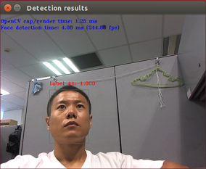

1. **Now we add (to the face detection) also an age and gender detection, running on the CPU**

$ ./lab.py interactive_face_detection_sample -i /dev/video0 -m FP16/face-detection-retail-0004 -d MYRIAD -m_ag age-gender-recognition-retail-0013 -d_ag CPU

InferenceEngine:

API version ............ 1.1

Build .................. 12419

[ INFO ] Parsing input parameters

[ INFO ] Reading input

[ INFO ] Loading plugin MYRIAD

API version ............ 1.1

Build .................. 12419

Description ....... myriadPlugin

[ INFO ] Loading plugin CPU

API version ............ 1.1

Build .................. lnx_20180510

Description ....... MKLDNNPlugin

[ INFO ] Loading network files for Face Detection

[ INFO ] Batch size is set to 1

[ INFO ] Checking Face Detection inputs

[ INFO ] Checking Face Detection outputs

[ INFO ] Loading Face Detection model to the MYRIAD plugin

[ INFO ] Loading network files for AgeGender

[ INFO ] Batch size is set to 16 for Age Gender

[ INFO ] Checking Age Gender inputs

[ INFO ] Checking Age Gender outputs

[ INFO ] Age layer: age_conv3

[ INFO ] Gender layer: prob

[ INFO ] Loading Age Gender model to the CPU plugin

[ INFO ] Head Pose DISABLED

[ INFO ] Emotions Recognition DISABLED

[ INFO ] Start inference

[ INFO ] Press any key to stop

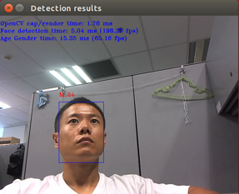

1. **Now let’s add head position detection running on GPU.**

$ ./lab.py interactive_face_detection_sample -i /dev/video0 -m FP16/face-detection-retail-0004 -d MYRIAD -m_ag age-gender-recognition-retail-0013 -d_ag CPU -m_hp head-pose-estimation-adas-0001 -d_hp GPU

InferenceEngine:

API version ............ 1.1

Build .................. 12419

[ INFO ] Parsing input parameters

[ INFO ] Reading input

[ INFO ] Loading plugin MYRIAD

API version ............ 1.1

Build .................. 12419

Description ....... myriadPlugin

[ INFO ] Loading plugin CPU

API version ............ 1.1

Build .................. lnx_20180510

Description ....... MKLDNNPlugin

[ INFO ] Loading plugin GPU

API version ............ 1.1

Build .................. ci-main-03703

Description ....... clDNNPlugin

[ INFO ] Loading network files for Face Detection

[ INFO ] Batch size is set to 1

[ INFO ] Checking Face Detection inputs

[ INFO ] Checking Face Detection outputs

[ INFO ] Loading Face Detection model to the MYRIAD plugin

[ INFO ] Loading network files for AgeGender

[ INFO ] Batch size is set to 16 for Age Gender

[ INFO ] Checking Age Gender inputs

[ INFO ] Checking Age Gender outputs

[ INFO ] Age layer: age_conv3

[ INFO ] Gender layer: prob

[ INFO ] Loading Age Gender model to the CPU plugin

[ INFO ] Loading network files for Head Pose detection

[ INFO ] Batch size is sey to 16 for Head Pose Network

[ INFO ] Checking Head Pose Network inputs

[ INFO ] Checking Head Pose network outputs

[ INFO ] Loading Head Pose model to the GPU plugin

[ INFO ] Emotions Recognition DISABLED

[ INFO ] Start inference

[ INFO ] Press any key to stop

